**Assignment 4 Report**

Q1)

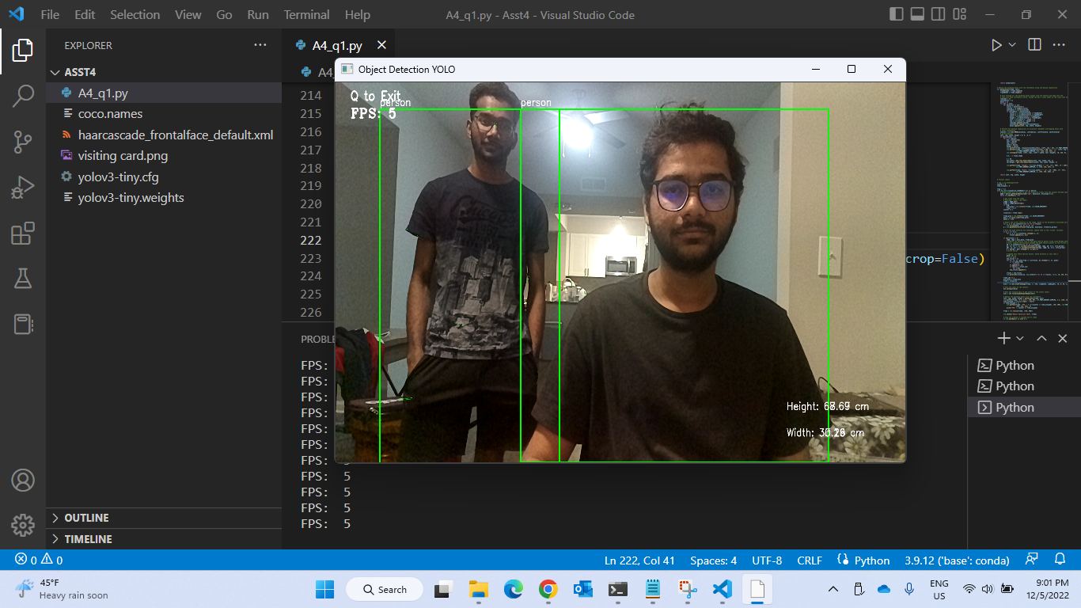

Q2)

